

***Caroling at “The Plaza”***

*Sunday, 12/11/16- 5:00- 8:00 P.M.*

**Archbald Borough High School Memorial Park**

***Laurel St. & Salem Rd.***

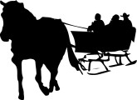 ***Horse-drawn Sleigh Rides- 5:30-8:00 P.M.***

***Caroling ***

***[](http://www.webweaver.nu/clipart/img/holidays/christmas/santa3.gif) Santa arrives aboard the Fire Truck***

***Refreshments served C:\Users\jpetronc\AppData\Local\Microsoft\Windows\Temporary Internet Files\Content.IE5\02IO3701\MC900053545[1].wmf***

